ParkSense – AI-Powered Intelligent Parking Management System
MACHINE LEARNING PRACTICE
PROJECT REPORT
Submitted by
SHERWIN JOSHVA J
RA2411003050219
DEEPAK KUMAR N
RA2411003050213
VASHEEM A
RA2411003050273
Under the guidance of
Dr. M. BHUVANESWARI M.Sc., M. Phil., Ph. D
(Professor, School of Computing)
in partial fulfilment for the award of the degree of
BACHELOR OF TECHNOLOGY
in
COMPUTER SCIENCE AND ENGINEERING
FACULTY OF ENGINEERING AND TECHNOLOGY

SRM INSTITUTE OF SCIENCE AND TECHNOLOGY
TIRUCHIRAPPALLI

SRM INSTITUTE OF SCIENCE AND TECHNOLOGY
(Deemed to be University U/S 3 of UGC Act, 1956)

BONAFIDE CERTIFICATE
Certified that this project report titled “ParkSense – AI-Powered Intelligent Parking Management System” is the bonafide work of Sherwin Joshva J (RA2411003050219), Deepak Kumar N (RA2411003050213), and Vasheem A (RA2411003050273), who carried out the project work under the guidance of Dr. M. BHUVANESWARI M.Sc., M. Phil., Ph. D.,(Assistant Professor,Department of Computer Applications), SRM Institute of Science and Technology, Tiruchirappalli.
Certified further, that to the best of our knowledge, the work reported herein does not form part of any other project report or dissertation on the basis of which a degree or award was conferred on an earlier occasion.
SIGNATURE SIGNATURE
Dr. M. Bhuvaneswari M.Sc., M. Phil., Ph. D Dr. S. Kanaga Suba Raja
Professor, School of Computing Associate Professor and Head (CSE)
SRM Institute of Science and Technology SRM Institute of Science and Technology

SRM INSTITUTE OF SCIENCE AND TECHNOLOGY
TIRUCHIRAPPALLI

DECLARATION
We hereby declare that the work contained in this project report titled “ParkSense – AI-Powered Intelligent Parking Management System” has been carried out by the undersigned team members at SRM Institute of Science and Technology, Tiruchirappalli, under the guidance of Dr. M. Bhuvaneswari, Professor, School of Computing.
We further declare that this report is prepared for academic purposes. The system description and analysis are based on the project scope supplied by the team. Implementation details, screenshots, and measured outputs must be verified against the final source code and deployed application before submission.
Place: Tiruchirappalli
Date: __________________
SHERWIN JOSHVA J DEEPAK KUMAR N VASHEEM A

ABSTRACT
Parking demand in busy urban and institutional areas creates difficulty for drivers who spend time searching for available spaces. Manual parking management can lead to uncertainty, inefficient use of parking areas, congestion near entrances, and limited visibility into demand patterns. ParkSense – AI-Powered Intelligent Parking Management System is a web-based smart parking solution that combines parking discovery, slot booking, and booking-data analysis in one platform.
The system is designed to allow users to view nearby parking facilities, inspect available options, and reserve a suitable parking slot through an online interface. This booking workflow aims to reduce the uncertainty involved in finding a parking space. The platform also analyses booking records to identify areas with high demand, days on which bookings are frequent, and parking or booking types that are selected most often.
The analytical component converts booking records into area-wise, day-wise, and type-wise summaries. These insights can help parking operators understand demand concentration, plan capacity, and improve allocation of parking resources. The project therefore combines a practical reservation workflow with descriptive data analytics. Predictive machine-learning functionality is not claimed unless it is separately implemented and validated.
This report presents the problem background, objectives, existing-system limitations, proposed architecture, system modules, implementation considerations, testing approach, results framework, conclusion, and future enhancements.

TABLE OF CONTENTS
S. No. | CONTENTS | PAGE
 | BONAFIDE CERTIFICATE | 2
 | DECLARATION | 3
 | ABSTRACT | 4
 | LIST OF FIGURES AND TABLES | 6
1 | INTRODUCTION | 7
1.1 | INTRODUCTION, PROBLEM STATEMENT AND OBJECTIVES | 7
1.2 | SCOPE AND MOTIVATION | 8
2 | EXISTING SYSTEM | 9
2.1 | OVERVIEW AND LIMITATIONS | 9
3 | DESIGN AND PROPOSED METHODOLOGY | 11
3.1 | SYSTEM ARCHITECTURE | 11
3.2 | METHODOLOGY AND REQUIREMENTS | 12
3.3 | DATA MODEL AND ANALYTICS | 14
4 | IMPLEMENTATION | 15
4.1 | IMPLEMENTATION OVERVIEW | 15
4.2 | SYSTEM MODULES | 15
4.3 | ALGORITHM, SECURITY AND VALIDATION | 16
5 | RESULT AND DISCUSSION | 18
5.1 | EXPECTED OUTPUTS | 18
5.2 | AREA-WISE AND DAY-WISE BOOKING ANALYSIS | 20
5.3 | TYPE-WISE ANALYSIS AND TESTING | 21
5.4 | TEST CASES AND DISCUSSION | 23
6 | CONCLUSION AND FUTURE ENHANCEMENT | 24
7 | REFERENCES | 25

LIST OF FIGURES AND TABLES

LIST OF FIGURES
5.1 ParkSense Login Page; 5.2 User Dashboard and Available Parking Spaces; 5.3 Parking Space Owner Details Form; 5.4 Parking Details and Availability Form; 5.5 Vehicle Type and Payment Options

LIST OF TABLES
2.1 Comparison of Existing and Proposed System; 3.1 Functional Requirements; 3.2 Non-Functional Requirements; 3.3 Main Data Entities; 4.1 System Module Description; 5.1 Test Cases; 5.2 Booking Analytics Measures
CHAPTER 1
INTRODUCTION

1.1 INTRODUCTION, PROBLEM STATEMENT AND OBJECTIVES
Parking is an essential part of transportation infrastructure. As the number of vehicles and daily trips increases, demand for organized parking spaces also increases. In commercial centres, educational institutions, offices, hospitals, and public places, drivers may spend considerable time locating a suitable parking area. When availability information is not accessible before arrival, vehicles circulate around parking locations, creating delay and contributing to local congestion.Conventional parking facilities may depend on manual supervision, paper records, physical display boards, or entry-and-exit registers. These approaches can work for small facilities, but they provide limited support when several parking areas must be monitored. A driver may not know which nearby facility has free capacity, while an operator may not have a consolidated view of reservations and demand trends.
ParkSense addresses this problem through a web-based parking management platform. Users can explore nearby parking facilities, view relevant information, and book an available slot. The system also retains booking information that can be analysed to understand how demand changes across locations, days, and parking categories.
Problem statement: users lack a convenient way to discover and reserve nearby parking, while operators lack an integrated view of booking demand by area, day, and type. The project aims to connect parking discovery, slot reservation, and booking-data analysis in one platform.
The objectives are to provide a centralized parking interface; display nearby facilities; support slot selection and booking; maintain structured booking records; analyse bookings by area, day, and type; identify high-demand locations and peak days; and present understandable summaries for operational planning.

1.2 SCOPE AND MOTIVATION
The scope of ParkSense covers user-facing parking discovery and reservation together with descriptive analysis of booking records. The system is intended to support multiple parking locations and provide information that helps a user choose a suitable nearby facility. The booking module records the selected facility, slot, date or time information, and booking category as supported by the application.
Area-wise analysis compares booking volumes across parking locations. Day-wise analysis groups bookings by weekday or calendar date to identify high-activity periods. Type-wise analysis compares the parking or booking categories maintained by the application. The exact category names must match the fields configured in the deployed system.
The motivation is to reduce the effort involved in locating parking and to make booking records useful for operational planning. A consolidated interface can improve user convenience, while analysis of historical booking activity can help operators recognize demand patterns. The project demonstrates how a web application and basic data analytics can be combined to address a practical urban-management problem.
The current stated scope is descriptive analytics. A high booking count indicates observed demand in the analysed records; it does not guarantee future demand. Predictive models, IoT occupancy sensing, automatic number-plate recognition, and dynamic pricing are possible future extensions rather than assumed existing features.

CHAPTER 2
EXISTING SYSTEM

2.1 OVERVIEW AND LIMITATIONS
In many parking environments, availability is communicated through manual boards, attendants, phone calls, or entry-gate observations. A driver generally reaches a facility and checks whether space is available. If the facility is full, the driver must search for another location. This process is reactive because availability is known only after the user reaches the facility.
Some facilities use digital payment or ticketing systems. These may improve payment processing and record keeping, but they do not necessarily provide a common discovery interface for nearby facilities. A payment-focused system may record completed transactions without offering a consolidated view of available slots across locations.
Booking information may also be maintained in spreadsheets or registers. Although these records preserve transaction history, manual grouping and comparison are required to understand demand. Operators may need to filter records by location and date to determine which area was busiest on a particular day.
The limitations include limited availability visibility, manual search effort, fragmented booking records, limited demand analysis, delayed decision-making, and reduced user convenience. ParkSense aims to address these limitations through a centralized interface, structured booking records, and analytical summaries.

ASPECT | TRADITIONAL APPROACH | PARKSENSE APPROACH
Discovery | Manual enquiry or separate sources | Centralized listing and nearby parking discovery
Reservation | Manual or separate process | Web-based slot selection and booking
Records | Paper or fragmented records | Structured booking records
Analysis | Manual review | Area-wise, day-wise and type-wise summaries
Planning | Limited consolidated visibility | Data-informed view of observed demand

CHAPTER 3
DESIGN AND PROPOSED METHODOLOGY

3.1 SYSTEM ARCHITECTURE
The ParkSense architecture consists of user interaction, application processing, data storage, booking management, and analytics presentation. A user accesses the web application through a browser. The interface presents parking information and accepts search and booking inputs. The application validates requests, checks the relevant slot information, and records a booking when the selected slot is eligible.
The data layer stores core entities such as users, parking areas, slots, and bookings. The analytics component reads booking records and groups them according to location, day, and parking type. The resulting summaries are displayed as tables, counts, or charts in the analytics view.
Overall flow: User / Administrator → Web Interface → Application Logic → Parking and Booking Database → Booking Processing → Booking Records → Analytics Processing → Area-wise, Day-wise and Type-wise Results.
The architecture is modular. The user module manages access. The parking discovery module presents nearby options. The booking module manages slot selection and reservation. The data-management module stores and retrieves records. The analytics module aggregates booking data and prepares visual summaries.
LAYER | RESPONSIBILITY
Presentation | Displays parking listings, booking forms, and analytics.
Application | Processes search, validates booking requests, and manages workflow.
Data | Stores users, parking areas, slots, and booking records.
Analytics | Groups bookings by area, day, and type and prepares summaries.

3.2 PROPOSED METHODOLOGY AND REQUIREMENTS
Step 1 – User access: the user opens the ParkSense web application and accesses the parking features. If authentication is enabled, the user signs in before protected operations.
Step 2 – Parking discovery: the application displays parking facilities and relevant details. Nearby options help the user identify facilities close to the selected location. Distance and map behaviour depend on the location services configured in the application.
Step 3 – Slot selection: the user selects a facility and reviews the slot information displayed by the system.
Step 4 – Booking submission: the user enters the required details. The application validates mandatory fields and checks whether the selected slot can be reserved.
Step 5 – Record creation: after successful validation, booking information is stored and a confirmation message is displayed according to the implemented interface.
Step 6 – Analytics: booking records are grouped by parking area, booking day, and parking or booking type. Counts are calculated and presented through tables or charts.
Functional requirements include parking listing, nearby discovery, slot selection, booking validation, booking-record management, and analytics generation. Non-functional requirements include usability, reliability, security, maintainability, performance, scalability, and data quality.

ID | REQUIREMENT | DESCRIPTION
FR-01 | Parking listing | Display parking areas and relevant details.
FR-02 | Nearby discovery | Show nearby options using configured location data.
FR-03 | Slot selection | Allow selection from displayed slots.
FR-04 | Booking | Validate and store a booking request.
FR-05 | Record management | Retrieve and manage booking information.
FR-06 | Analytics | Aggregate records by area, day, and type.

3.3 DATA MODEL AND BOOKING ANALYTICS
The data model represents the information needed to support parking discovery and reservation. The following entities are a suggested logical model; field names should be aligned with the actual database schema used by the team.
ENTITY | EXAMPLE FIELDS | PURPOSE
User | user_id, name, contact | Represents a platform user.
ParkingArea | area_id, area_name, location | Stores parking facility details.
ParkingSlot | slot_id, area_id, slot_type, status | Represents an individual slot.
Booking | booking_id, user_id, slot_id, date, type, status | Stores reservation information.

Area-wise analysis groups valid booking records by parking area and counts the records in each group. Sorting the counts in descending order identifies the location with the highest booking activity for the selected period.
Day-wise analysis extracts the weekday or calendar date from each booking and counts records for each group. Type-wise analysis groups records using the parking type or booking category field available in the database.
For a selected dataset D, Count(g) is the number of valid booking records belonging to group g. The highest-demand group is the group with the maximum count. This is descriptive analytics and does not, by itself, predict future demand.
Cancelled, expired, or test bookings must be handled consistently. The team should define whether such records are excluded from demand counts and apply the same rule to all charts.

CHAPTER 4
IMPLEMENTATION

4.1 IMPLEMENTATION OVERVIEW
ParkSense is presented as a web-based application. The team has shared the partially completed project interface at https://smartcityparking.onrender.com. The final report should include screenshots captured from the actual running application after the relevant modules are completed and verified.
The implementation can be organized into a presentation layer, application layer, data layer, and analytics layer. The presentation layer contains the pages and controls used by users. The application layer processes search and booking requests. The data layer stores parking and booking information. The analytics layer aggregates records and generates summaries.
The exact programming language, database engine, mapping provider, and charting library must be confirmed from the project source code. They are not assumed in this report. The team should update the implementation details to match the technologies actually used.
4.2 SYSTEM MODULES

User Module
The user module provides the entry point to the platform. If registration and login are implemented, account validation should occur before protected booking operations.

Parking Discovery Module
This module presents parking areas with identifying information such as name, location, and availability. Nearby parking is intended to help users discover facilities close to the selected area.

Slot Booking Module
The user selects a parking facility and a slot, enters required details, and submits the request. The application validates the request before storing the reservation.

Booking Management Module
Booking records are maintained with relevant identifiers, dates, categories, and statuses. Authorized users may retrieve or manage records according to application permissions.

Analytics Module
This module retrieves valid booking records, groups them by area, day, and type, and displays the results through charts or tables.
4.3 ALGORITHM, SECURITY AND VALIDATION
The following technology-neutral algorithm describes the intended booking aggregation process:
INPUT: booking records, selected date range, and record inclusion rules.; 1. Retrieve bookings whose dates fall within the selected range.; 2. Apply the agreed status rule, such as excluding cancelled or test records.; 3. Group filtered records by parking area and count each group.; 4. Group records by weekday or calendar date and count each group.; 5. Group records by parking or booking type and count each group.; 6. Sort grouped results when ranking is required.; 7. Display counts and charts with the selected date range.; OUTPUT: area-wise, day-wise, and type-wise booking summaries.
Input validation should be performed on the server side even when browser-side validation is also provided. Access to administrative analytics and booking-management functions should be restricted to authorized users. User credentials, if stored, must be protected appropriately.
Booking validation should prevent invalid slot references and conflicting reservations where time-window booking is supported. Database operations should handle simultaneous requests safely. Error messages should be clear without exposing internal database details.
Data quality is essential. Dates should use a consistent format, area identifiers should refer to existing facilities, and category values should come from controlled lists where possible. Duplicate and incomplete records can distort the charts and should be checked.
CHAPTER 5
RESULT AND DISCUSSION

5.1 EXPECTED OUTPUTS
The expected output of ParkSense is a connected workflow in which users can discover nearby parking facilities, select a suitable slot, and submit a booking request. Booking records generated through this workflow provide the input for the analytics module.
The analytical output addresses three questions: which parking area has the highest number of bookings, which day has the highest booking activity, and which parking or booking type is selected most often. These questions correspond directly to the project requirements.
No numerical performance values are stated here because a verified booking dataset and measured outputs have not been supplied. The final report should include actual counts generated by the completed application.

5.1.1 User Interface Output
The home page should introduce ParkSense and provide navigation to the main parking functions. The nearby parking page should show facilities returned by the application. The booking page should display the selected facility and slot, collect required details, and provide confirmation or an error message.

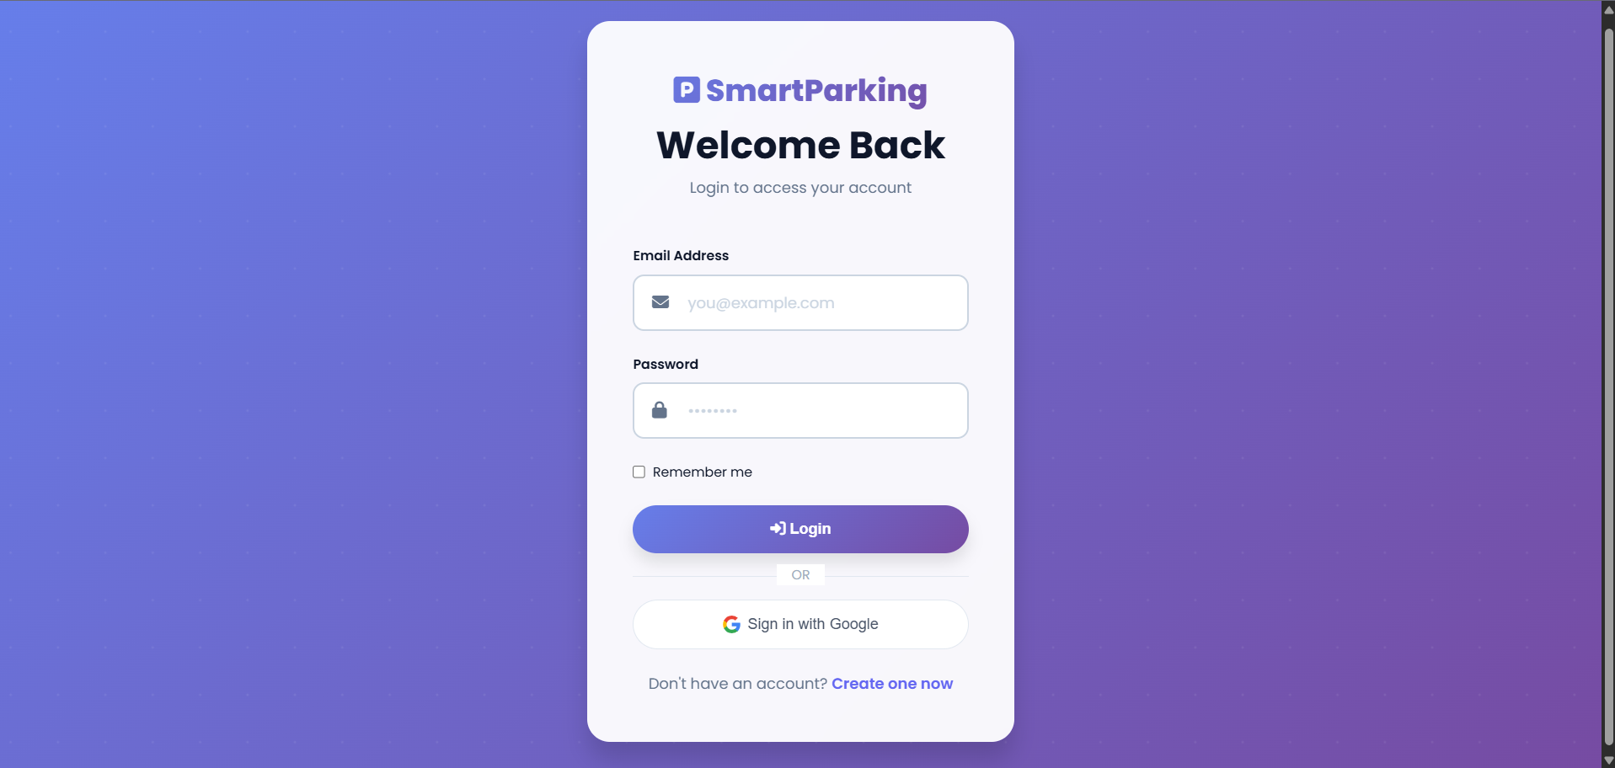
Fig. 5.1 – ParkSense Login Page

Fig. 5.2 – User Dashboard and Available Parking Spaces
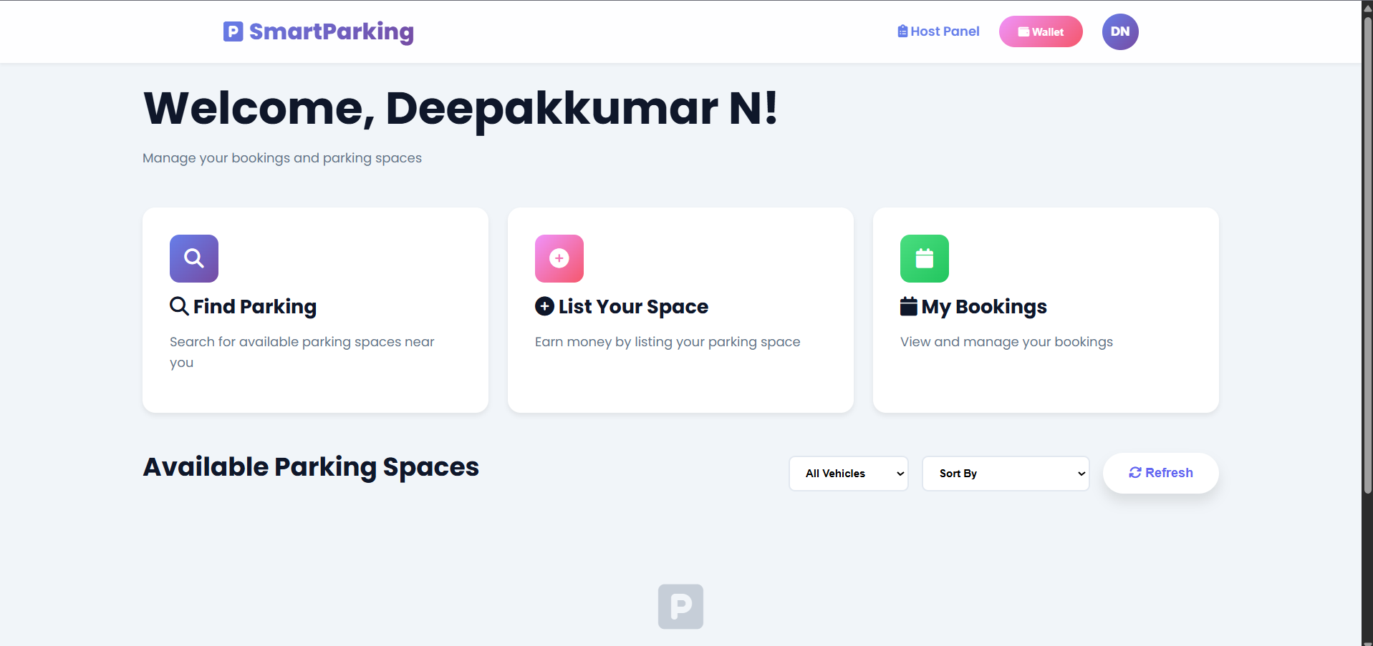

5.2 AREA-WISE AND DAY-WISE BOOKING ANALYSIS

Area-wise Booking Analysis
Area-wise analysis compares the number of bookings associated with each parking location. The result helps an operator identify facilities that receive a larger share of reservations during the selected period. A bar chart is suitable because it allows booking counts across locations to be compared directly.
Fig. 5.3 – Parking Space Owner Details Form
The area with the largest count can be reported as the highest-booking area for the selected date range. The report should mention the analysis period and the number of valid booking records included. The chart must be generated from actual application data.
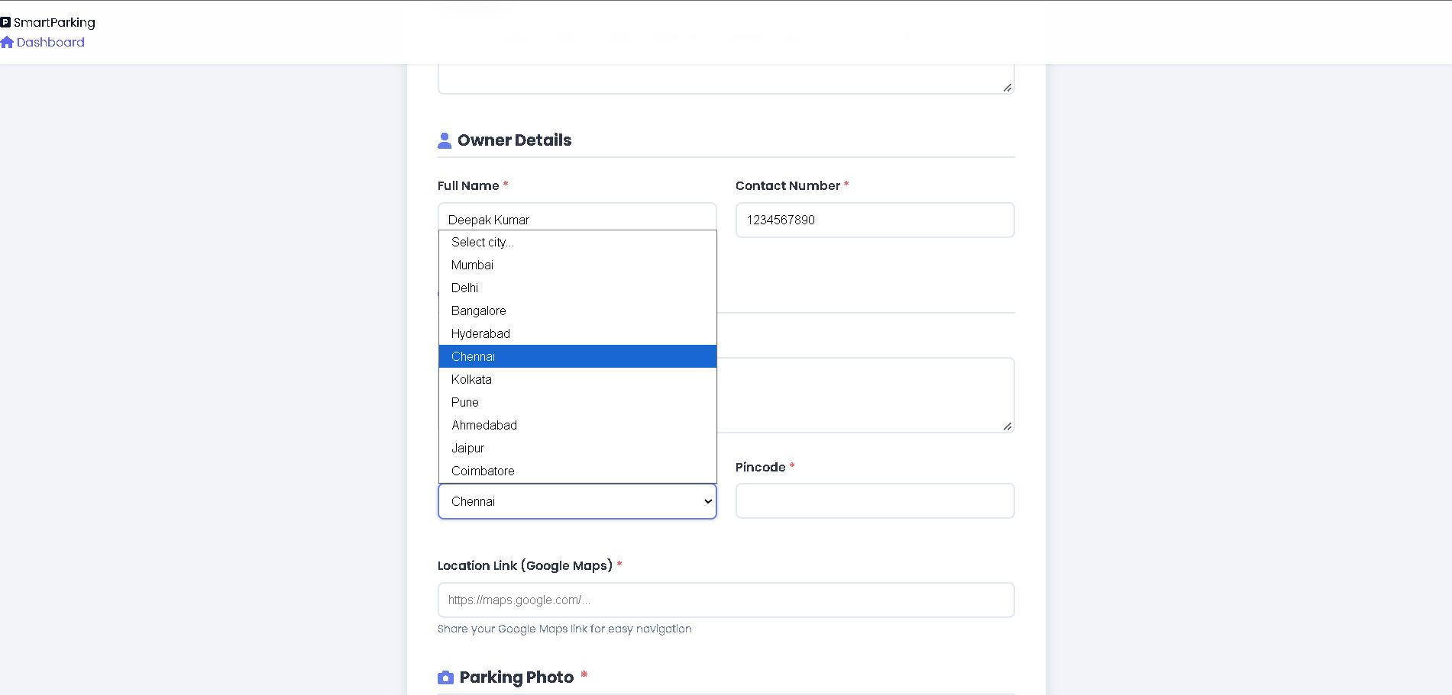

Day-wise Booking Analysis
Fig. 5.4 – Parking Details and Availability Form
Day-wise analysis groups booking records by weekday or calendar date. A weekday comparison can reveal whether booking activity is concentrated on particular days. For a weekday chart, the order should be Monday to Sunday. Days with no bookings should be represented clearly when a complete weekly pattern is intended.
The highest count indicates the peak day in the selected dataset. The interpretation should identify the busiest and lowest-activity days only when supported by the chart.
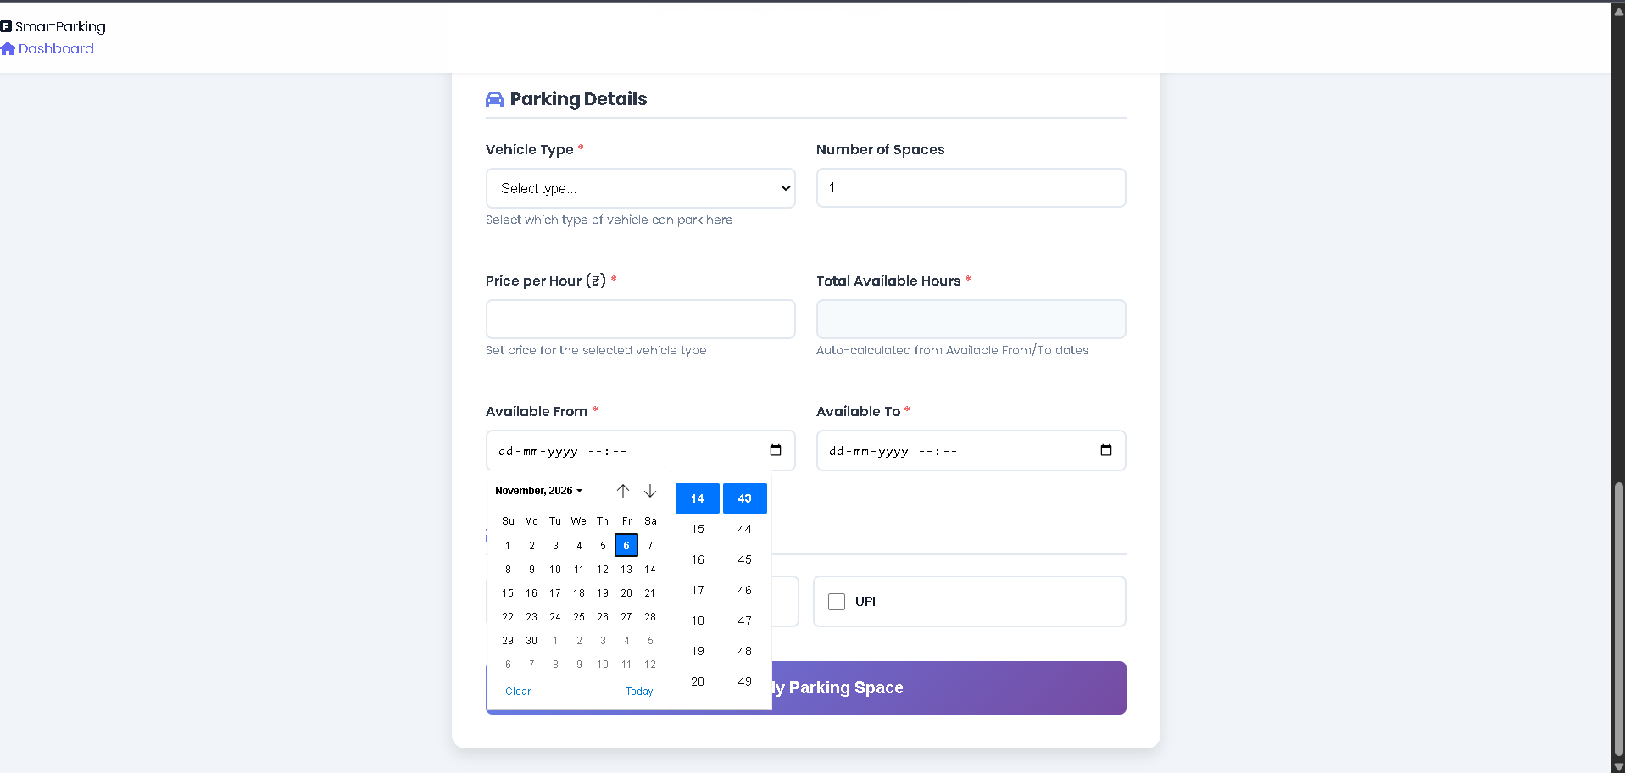

5.3 TYPE-WISE ANALYSIS AND TESTING

Type-wise Booking Analysis
Fig. 5.5 – Vehicle Type and Payment Options
Type-wise analysis compares the number of bookings across categories maintained by the application. Depending on the actual schema, categories may represent vehicle types, slot types, or booking types. The final report must use the exact field and category labels present in the deployed system.
A bar chart or pie chart can show category distribution. A bar chart is useful when category names are long or exact counts must be compared. A pie chart can show each category’s share of the total. The interpretation should identify the most frequently selected category using actual counts or percentages.

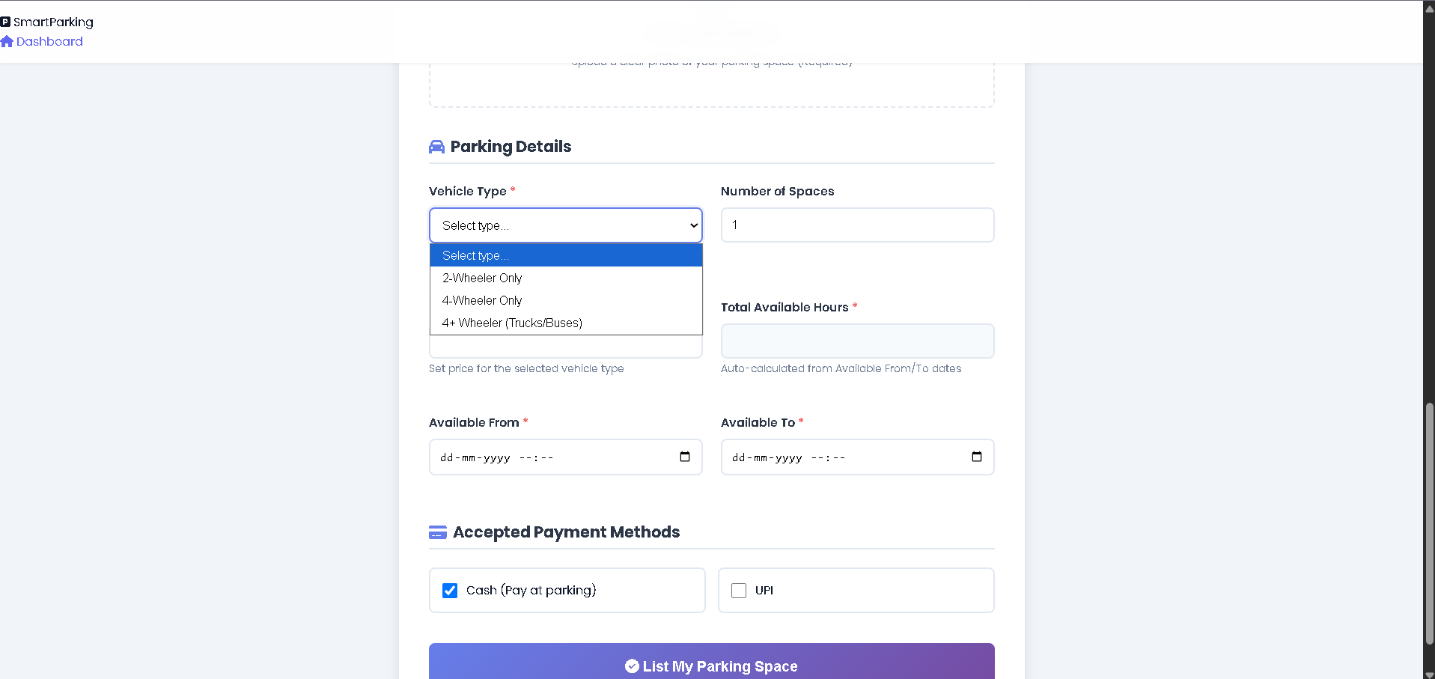

Testing and Validation
Testing confirms that the main user actions work as intended and that analytical summaries are consistent with the underlying records. Functional testing should cover parking listing, nearby search, slot selection, booking submission, and analytics generation. Boundary testing should include missing fields, invalid dates, unavailable slots, and records outside the selected date range.
Analytics validation should compare chart totals with independently counted booking records. The sum of area-wise counts should match the number of included bookings if every booking belongs to exactly one area. The same principle applies to day-wise and type-wise counts when each record has exactly one value for the grouping field.

5.4 TEST CASES AND DISCUSSION
TEST ID | TEST SCENARIO | EXPECTED RESULT | STATUS
TC-01 | Open parking listing | Parking facilities are displayed | To be tested
TC-02 | Search nearby parking | Relevant nearby results are displayed | To be tested
TC-03 | Select an available slot | Slot can be selected | To be tested
TC-04 | Submit valid booking | Booking is stored and confirmation shown | To be tested
TC-05 | Submit incomplete booking | Validation message is displayed | To be tested
TC-06 | Select unavailable slot | Booking is rejected or refreshed | To be tested
TC-07 | Generate area-wise analysis | Counts match valid booking records | To be tested
TC-08 | Generate day-wise analysis | Counts match valid booking records | To be tested
TC-09 | Generate type-wise analysis | Counts match valid booking records | To be tested

The test cases should be executed against the final deployed version. The status column must be updated with Pass or Fail after actual verification. Any failed test should be documented with the observed behaviour and corrective action.
The usefulness of the analytics depends on accurate booking dates, consistent area identifiers, reliable category labels, and a clear rule for handling cancelled or test bookings. Charts should state the date range and number of records included so that the results can be interpreted correctly.

CHAPTER 6
CONCLUSION AND FUTURE ENHANCEMENT

6.1 CONCLUSION
ParkSense – AI-Powered Intelligent Parking Management System presents a unified approach to parking discovery, slot booking, and booking-data analysis. The system is designed to help users identify nearby parking facilities and reserve a suitable slot through a web interface. By maintaining structured booking records, the platform also provides a basis for analysing demand across parking areas, days, and parking categories.
The main contribution is the connection between the operational booking workflow and the analytical use of booking history. Area-wise analysis can reveal which facilities receive the most reservations. Day-wise analysis can show when booking activity is comparatively high. Type-wise analysis can identify the categories most frequently selected. These summaries can help operators understand observed demand and support operational planning.
The project demonstrates the importance of data validation and consistent records. The application should be tested with real project data before numerical conclusions are included in the final report.

6.2 FUTURE ENHANCEMENTS
Live occupancy updates through IoT sensors or parking-gate integration.; Map-based navigation and more accurate distance calculation using a verified mapping service.; Automated booking notifications through email, SMS, or in-app alerts.; Predictive demand modelling using sufficient historical booking data and a validated machine-learning method.; Capacity planning based on observed and predicted demand.; Administrative dashboards with date filters, exportable reports, and configurable parking categories.; Payment gateway integration and digital receipts, if required.; Improved authentication, audit logs, and privacy-aware data retention.
REFERENCES
[1] J. Han, M. Kamber, and J. Pei, Data Mining: Concepts and Techniques, 3rd ed. Morgan Kaufmann, 2011.
[2] M. J. A. Berry and G. S. Linoff, Data Mining Techniques: For Marketing, Sales, and Customer Relationship Management, 3rd ed. Wiley, 2011.
[3] A. Silberschatz, H. F. Korth, and S. Sudarshan, Database System Concepts, 7th ed. McGraw-Hill, 2019.
[4] R. S. Pressman and B. R. Maxim, Software Engineering: A Practitioner’s Approach, 9th ed. McGraw-Hill, 2020.
[5] Python Software Foundation, “Python Documentation.” https://docs.python.org/.
[6] PostgreSQL Global Development Group, “PostgreSQL Documentation.” https://www.postgresql.org/docs/.
[7] W3C, “Web Content Accessibility Guidelines (WCAG) 2.2.” https://www.w3.org/TR/WCAG22/.
[8] OpenStreetMap contributors, “OpenStreetMap.” https://www.openstreetmap.org/ (if used by the application).
[9] ParkSense project application, “Smart City Parking – Project Interface.” https://smartcityparking.onrender.com.
[10] Project team, ParkSense project requirements and functional description, supplied for preparation of this report, 2026.

